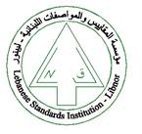
The Lebanese Standards Institution
Invites you to attend the

“Fundamentals of Project Management”
Training course

Offered by LIBNOR training center


Date: 23-24 July 2018
Time: 9:00am -4:00pm

Companies are invited to contact us to register nominated candidate on
training@libnor.org

